What is Legal Entity(LE)
A legal entity is an organization that has a registered or legislated legal structure. Legal entities can enter into legal contracts and are required to prepare statements that report on their performance.
A company is a type of legal entity. Currently, companies are the only kind of legal entity that you can create, and every legal entity is associated with a company ID

Creating a new Legal Entity in MS Dynamics 365
To create a new legal entity in Dynamics 365, follow these steps.
- In the navigation pane, Go to Modules > Organization administration > Organizations > Legal entities
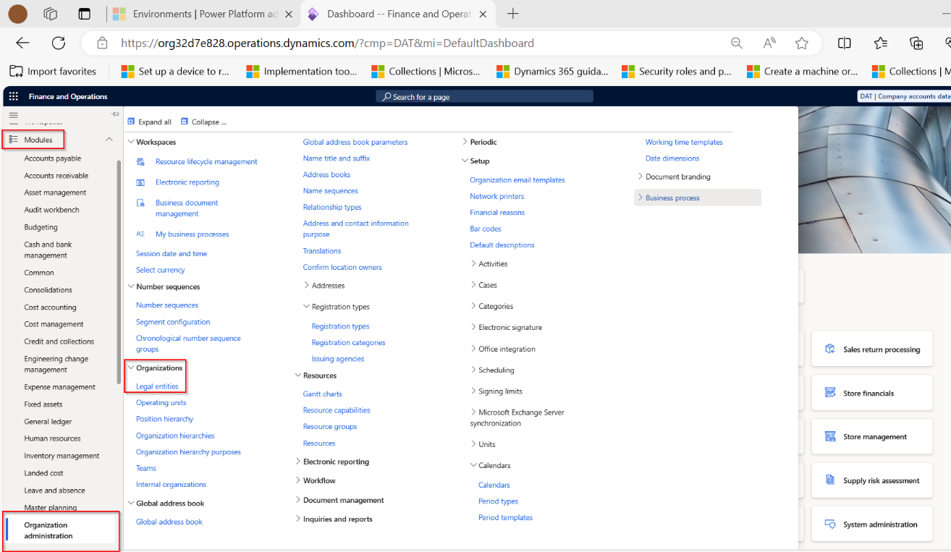
- On the action pane, select New. The New legal entity pane appears on the right.

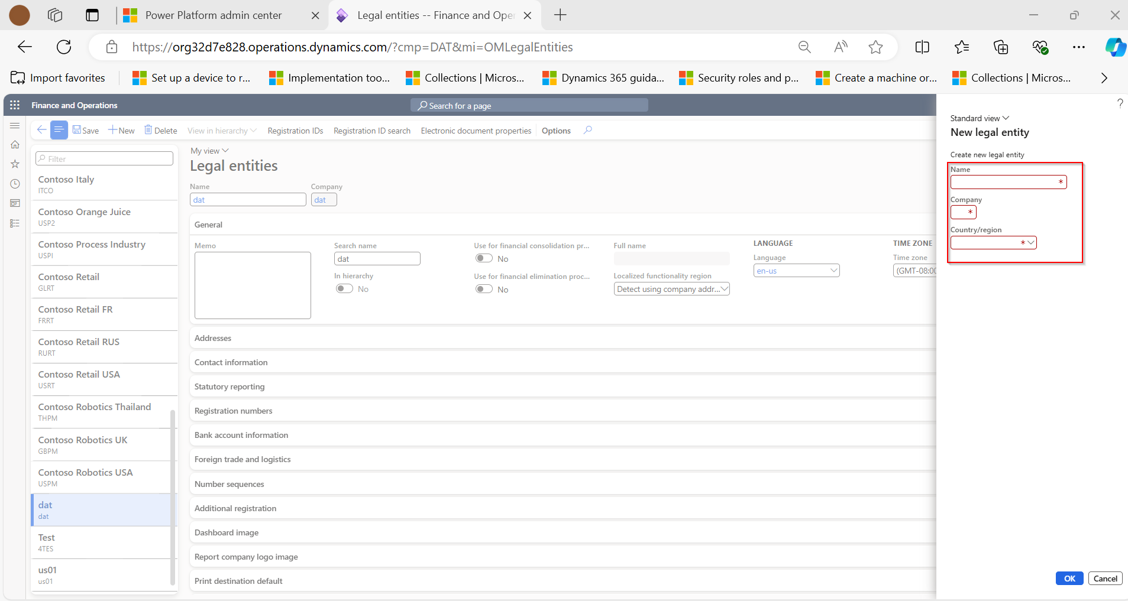
- In the Name field, enter a value. (Mandatory)
- In the Company field, enter a value. (Mandatory)
- In the Country/region field, enter or select a value. (Mandatory)
- Select OK.
Fast Tabs on Legal Entity Page
The legal entity has been created and following fast tabs are available on the newly created legal entity page.

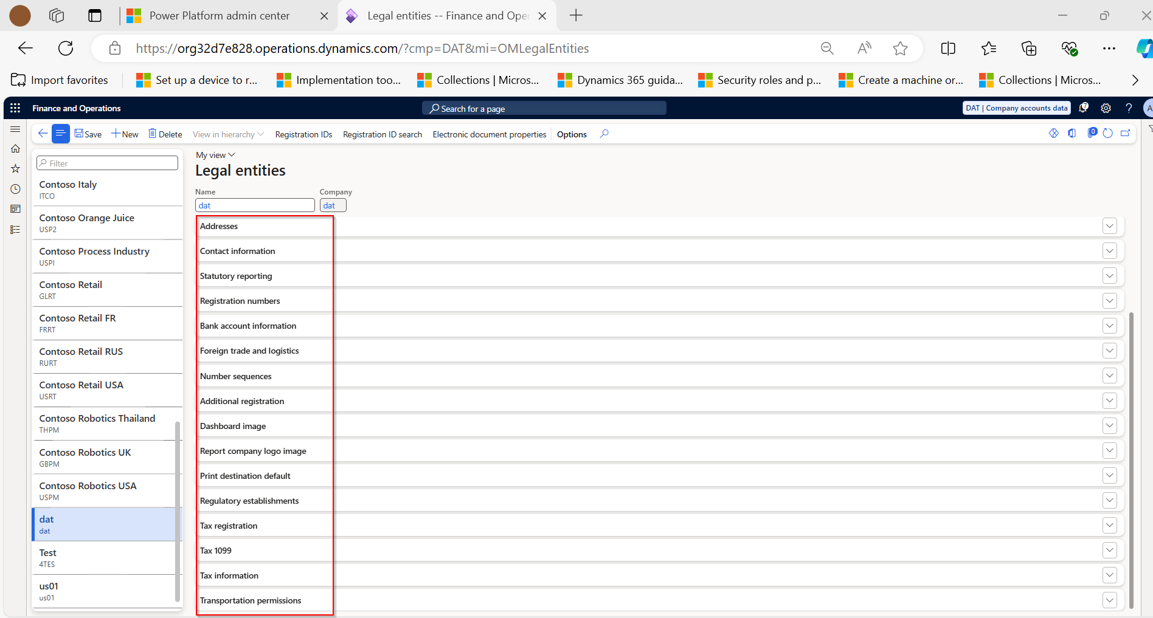
- General
- Additional Registration
- Address
- Dashboard Image
- Contact Information
- Report Company Logo Image
- Statutory Reporting
- Print Destination Default
- Registration Numbers
- Regulatory Establishments
- Bank Account Information
- Tax Registration
- Foreign Trade and Logistics
- Tax 1099
- Number Sequence
- Transportation Premises

In the General section,
- Provide the general information / description about the legal entity under Memo section.
- Enter a search name, if a search name is required under Search name section. A search name is an alternate name that can be used to search for this legal entity.
- Select whether this legal entity is being used as a consolidation company. If this legal entity is being used as a consolidation company, set the Use for financial consolidation process slider to Yes. No transactions will be posted, and the entity will only be consolidating the data / reports of the branch / subsiadiary companies.
- Select whether this legal entity is being used as an elimination company. If this legal entity is being used as an elimination company, set the Use for financial elimination process slider to Yes.
- Select the default language for the entity.
- Select the time zone for the entity.
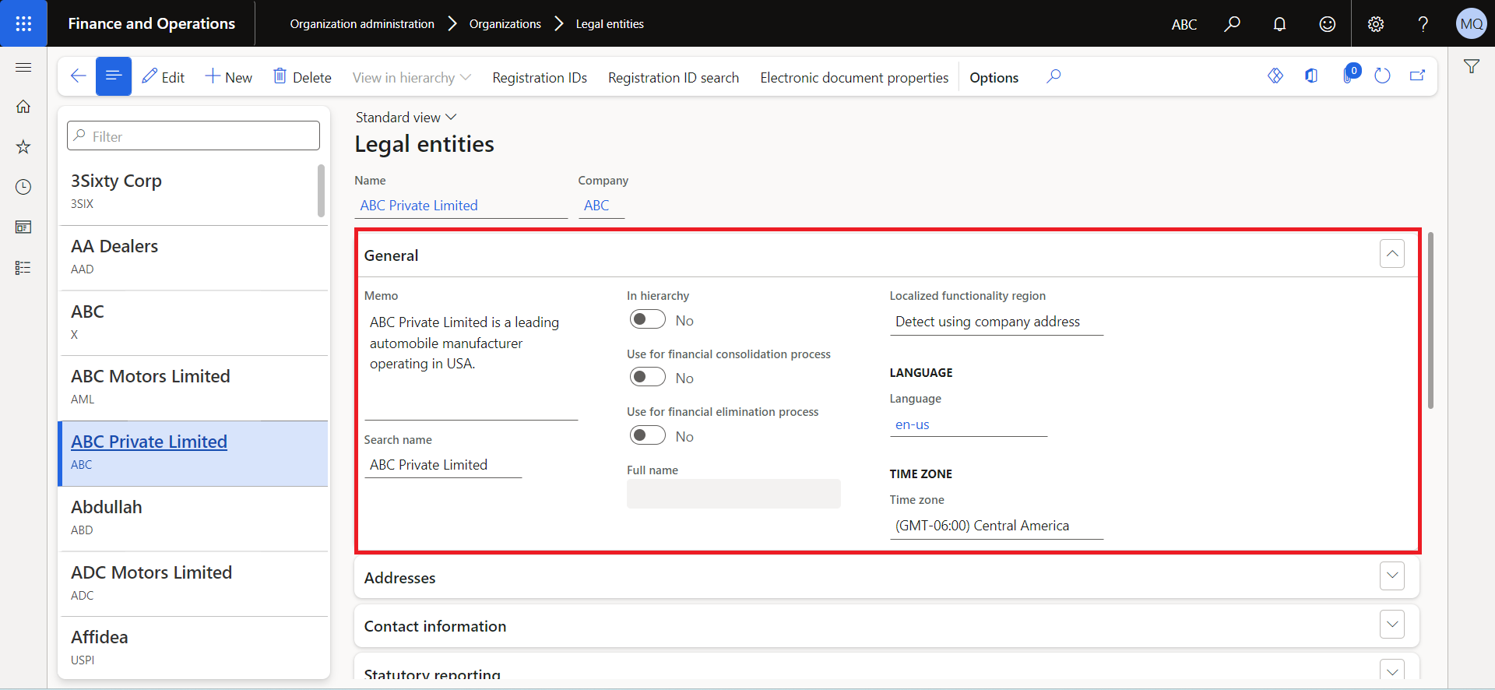
General Fast Tab Section

In the Addresses section,
- To enter new address information, select +Add.
- Select Edit to enter address information, such as the street name and number, postal code, and city.
You can add multiple addresses for different locations.
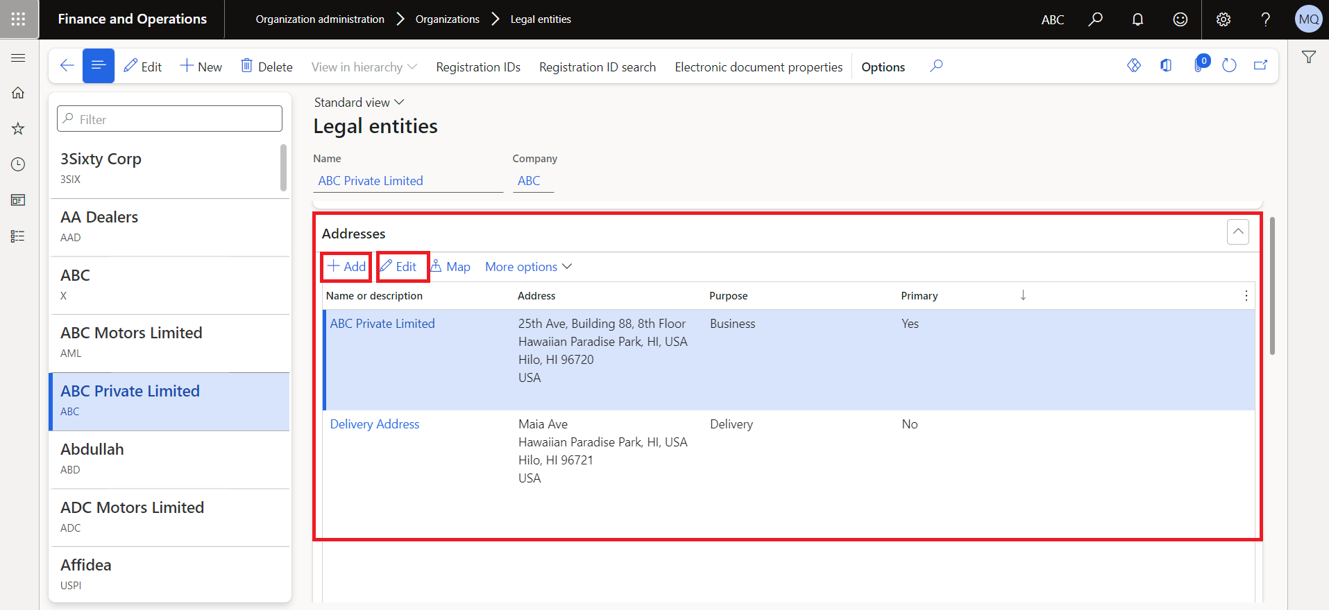
Address Fast Tab Section

In Contact information section,
- To enter a new contact information record, select Add.
- To modify an existing communication record, select Advanced.
- Enter information about methods of communication, such as email addresses, URLs, and telephone numbers.
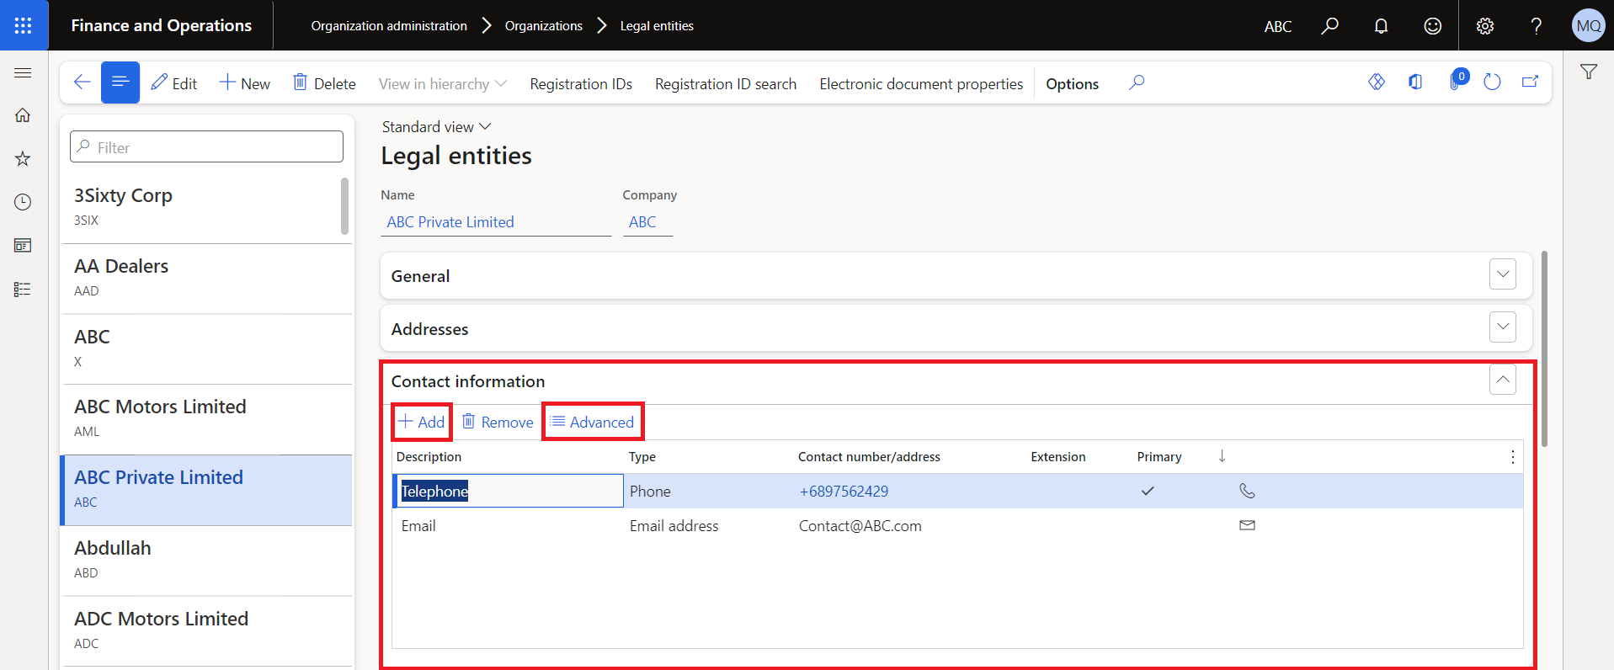
Contact Information Fast Tab Section

In the Statutory Reporting fast tab section, enter the details that are used for statutory reporting.
In the Registration Numbers fast tab section, enter any information required by the legal entity. The fields are enabled as per the country of the legal entity
In the Bank Account Information fast tab section, enter bank accounts and routing numbers for the legal entity. The bank details are recommended to be added in a separate module "Cash and bank management".
In the Foreign Trade and Logistics fast trade section, enter shipping information for the legal entity.
In the Number Sequences section, view the number sequences that are associated with the legal entity.
In the Dashboard Image section, view or change the logo and/or dashboard image that is associated with the legal entity.
In the Tax Registration fast tab section, enter the registration numbers that are used to report to tax authorities.
In the Tax 1099 fast tab section, enter 1099 information for the legal entity. (This is only necessary for a US-based company.)
Select Save.
The legal entity is saved and is available among the list of legal entities.
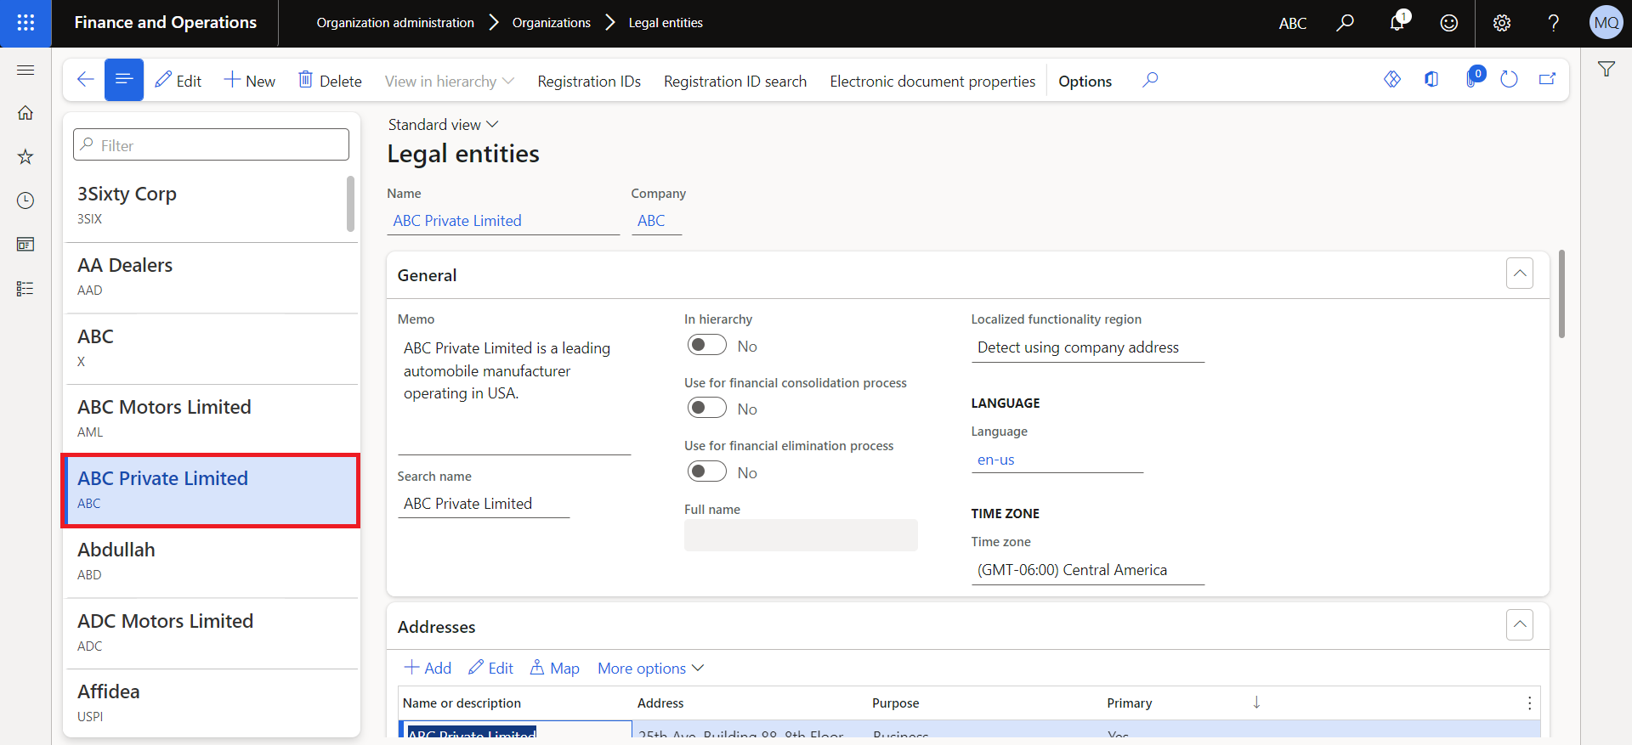

Also, the Legal Entity is available among the list of legal entities on Home Page.
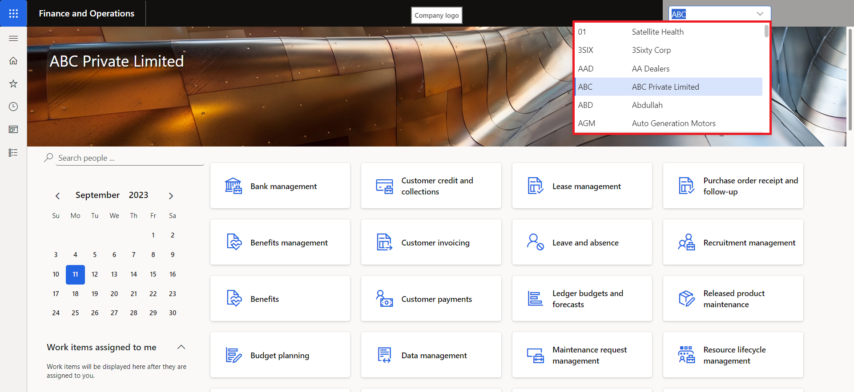

ADDITIONAL RESOURCES
https://learn.microsoft.com/en-us/dynamics365/fin-ops-core/fin-ops/organization-administration/tasks/create-legal-entity

